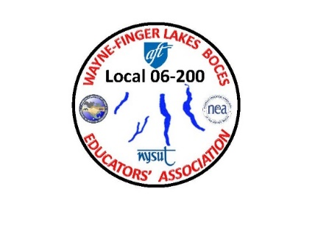
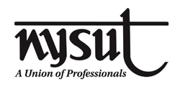
WAYNE-FINGER LAKES BOCES
EDUCATORS’ ASSOCIATION
LOCAL 06-200

Important information that you need to know. The following info was sent out via HR to all employees that the Federal Government and State have now implemented.

As of January 1, 2021, these Federal leave options are no longer available.
  - As a result, employees who are ill or caring for someone who is ill may use their accumulated sick time. The use of sick time is an affirmation of illness. Sick time should only be used as defined in the applicable contract and/or policy.
  - Employees who are providing childcare/supervision due to lack of in-person school or care provider closure, may only use personal or vacation time.
  - In the case that accumulated leave times are exhausted, employees may request an unpaid leave of absence based on their specific circumstances.
New York State (NYS) COVID-19 Paid Sick Leave
- The New York State (NYS) COVID-19 Paid Sick Leave continues to be available to all public employees into 2021.
- The New York State (NYS) COVID-19 Paid Sick Leave provides:
  - Continuing payment to employees who are unable to physically report to work due to an official issued quarantine order for the impacted employee by the Department of Health.
  - This leave is at the regular rate of pay, and the employee is not required to use their accrued time for the length of the governmental order for quarantine.
  - During quarantine, the employee will be marked absent as sick time initially; however, upon receipt and processing of the DOH Order, sick time will be adjusted to account for the quarantine dates, and the employee’s sick time will be re-credited.

Here are a few of the highlights of the NYS Paid Leave Law that is still in effect:

- A paid sick leave benefit of at least 14 days is available to any individual who is subject to a precautionary or mandatory quarantine issued by the Department of Health. Here is a link to information about obtaining a quarantine order [Obtain Order of Quarantine];
- This benefit is only available to the individual who is subject to quarantine and NOT available to use to care for a child or person for whom you are caring who may be subject to a quarantine order.
- NYSUT’s position is that this benefit is “at least 14 days” and not capped or limited to one incident of quarantine; however, there is no legal precedent on this issue, and it is likely to wind up in the courts. If one of your members is denied NYS Paid Leave due to an interpretation of the number of days available, please let me or your building rep know immediately; and
- This leave is NOT available for quarantines required due to voluntary out of state travel.

