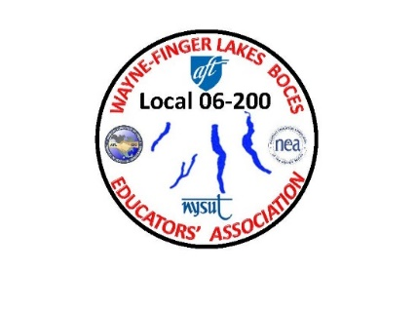
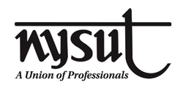
WAYNE-FINGER LAKES BOCES EDUCATORS’ ASSOCIATION
LOCAL 06-200

January 17, 2021

Dear WFLBEA Members:

First and foremost, I need to let everyone know that I am supportive and understanding of your concerns regarding this working school year. I am here to support and represent each union member within your best interest.

I have been working together with our NYSUT LRS (Labor Relations Specialist) Jon Hickey to help stay on top of the proper information. While at the same time keeping the communications between our union and BOCES open during these troubling times.
Since the start of the school year, I have been fielding emails, phone calls, and text messages regarding the dissatisfaction from members with the safety of our members due to different circumstances such as not having the proper PPE, cleanliness of rooms, and students with mask exemptions and now the vaccine just to name a few.
The governor has ordered that all schools to come up with exemptions forms for adults and students who have physical or mental health problems that prevent them from wearing masks.
I have been working with BOCES daily regarding many other issues. Anything that has been sent out by BOCES from Administration, has been discussed with Jon Hickey our (LRS) and/ or myself. Any information that is received has been shared between both sides so that we can keep everyone informed correctly.

Enclosed is information from BOCES and NYSUT pertaining to the new law requirements regarding the differences between normal sick time and NYS quarantine time.
Please remember that after this letter, I will be posting information on website instead of direct communication. This will easier for all members to find it and retrieve the information. The website once again is www.wflbea.org. Any article that needs to be downloaded and needs a password, is very easy. The password is: UNION.
In Solidarity,
James A. Buck
Jim Buck
WFLBEA Union President
1/17/21 JAB

