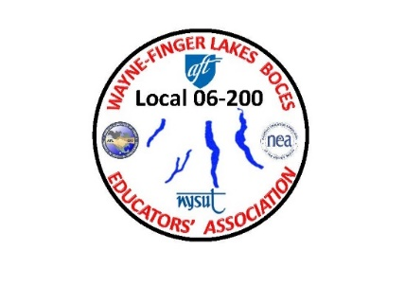WAYNE-FINGER LAKES BOCES

EDUCATORS’ ASSOCIATION

**LOCAL 06-200**

February 6th, 2021

Dear WFLBEA Members:

I hope this letter finds you all well. I am writing this letter to you all because of the email we received from BOCES (through our BOCES email) about the vaccine clinic for members from BOCES that work in Wayne County and supporting school districts. I would like to try and clear up a massive confusion that was brought to my attention this past week about the issue with the Wayne County Department of Health web link for the 1st round of vaccines that many members were upset about.

I heard from members that BOCES was responsible for the issue regarding the Wayne County Department of Health web link, this is further from the truth. All BOCES was doing was supplying the web link that was given to them. I also heard and know firsthand that the web link that was supplied was to open at 7:00 PM on Wednesday 2/3/2021. As many of you have let me know, when you went to the link at 7:00 PM the link showed that all the time slots were full.

I must admit that I tried it that night at 6:15 PM and was able to sign up for a time slot, and by 6:45 PM all time slots were full. Friday afternoon while I was at the Conference Center receiving my shot, I made a point to introduce myself to Diane Devlin, director of public health of Wayne county and explain to her what I heard and what I witnessed myself. Before I left the Conference Center, Ms. Devlin explained to me that after talking to the people that were in charge of the web link, that there was a mistake in the time setting.

First and foremost, Ms. Devlin deeply apologized for the mishap and assured me that the web link would be fixed so when it is sent out again by BOCES, that whatever the time is stated, that will be the time the link will open. I hope this helps to clear up any confusion or frustrations that many members have had.

To all members that work in the Ontario County area, I know that Ontario County is conducting the vaccine clinics differently so if there is any concerns or problems, please feel free to contact me and I will investigate the situation.

If you are concerned about receiving the vaccine, due to any underlying ailments that you might have, my suggestion is do what I did, contact your specialist and make sure that you are capable of receiving it.

In Solidarity,

James A. Buck

Jim Buck

WFLBEA Union President