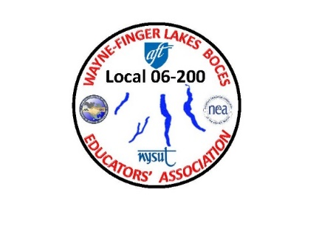WAYNE-FINGER LAKES BOCES

EDUCATORS’ ASSOCIATION

**LOCAL 06-200**

February 9, 2021

Dear WFLBEA members:

Well, here it is, three days after my other letter and I am writing another letter. As I have said before, “Just wait a day and things will change.” This is especially true now during the COVID-19 pandemic.

As you have noticed from the two emails that were sent out from Erin and Vicky today, the Wayne County DOH will be running their vaccine clinic the same as the Ontario County DOH. This means that names will be randomly pulled from the list that was given to them based on members who fill out the weekly questionnaire.

The reason for this change is because the link that was supplied to us from the Wayne County DOH is not working correctly. Please be aware that these vaccine clinics are for members that are interested in receiving their 1st dose of the vaccine.

I was in a meeting with Erin and Vicky this afternoon before they sent out the emails to make sure that I was aware of what was going to happen and to help answer any questions you all may have. Please be patient regarding the way the DOHs are running their clinics. BOCES has nothing to do with who gets notified next, they only supply them with the list of names from the questionnaire.

It is also important to note that there are many people in group 1a who still haven’t received their first dose of the vaccine yet.

Enjoy your week off next week. We all deserve it and need it.

In solidarity,

James A. Buck

Jim Buck

WFLBEA Union President