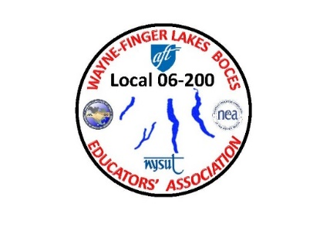

WAYNE-FINGER LAKES BOCES EDUCATORS’ ASSOCIATION

LOCAL 06-200

4/18/2021

**re: Spring Meeting and Call for Nominations 2nd NOTICE**

Greetings to all,

All members of the Wayne-Finger Lakes BOCES Educators’ Association, are invited to attend the 2021 **Spring Annual meeting, scheduled for 4:00 p.m. on Wednesday, May 12th at the Conference Center in Newark, and on Zoom @** Join Zoom Meeting <https://edutech.zoom.us/j/2032195058?pwd=d0dtVkp1anpjck5ZYmNCTzZaa0FDUT09>

Tentative agenda items include Fall 2020 Meeting Minutes, Treasurer’s Report, report from EA President Jim Buck, Meet the Candidates (**nominated and communicated to Executive Secretary Sue Morse by May 5th**), and Member Issues/Concerns. If you have any specific items or issues/concerns that you would like addressed at this meeting, please let me know (via email at jbuck-wflbea@rochester.rr.com) as soon as possible to facilitate inclusion on the meeting agenda.

Also included in this communication is a call for nominations for President and Executive Secretary of the W-FL BOCES Educators’ Association for the term of July 1, 2021 – June 30, 2023. Current officers are President Jim Buck and Executive Secretary Sue Morse. **The last day to communicate nominations to the Executive Secretary is Wednesday, May 5th**. Nominees should send bios to Sue as soon as possible and no later than May 7th. **Available candidate bios will be emailed to you no later than May 10th**. Assuming normal operations, **voting for officers will be conducted by your Building/Cluster Representatives by May29th**. If it is necessary to conduct on-line voting, a procedure will be communicated to you (voting timeline would remain at a May 29th completion date). Ballots will be counted at the June 13th Executive Council meeting. Please note that if all positions are uncontested, voting would be conducted at the Spring meeting. (**A nomination form is included in this email**.)

The WFLBEA officers and other executive council members look forward to seeing you on **May 12th**.

Regards,

James A. Buck

James A. Buck

President

W-FLB Educators’ Association

jbuck-wflbea@rochester.rr.com

315-729-8263