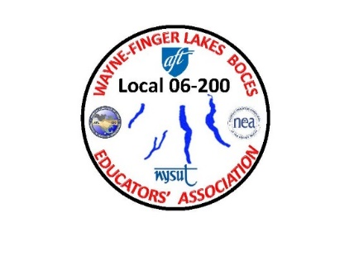 **WAYNE-FINGER LAKES BOCES**

**EDUCATORS’ ASSOCIATION**

**LOCAL 06-200**

September 2021

Dear Fellow Union Members:

It has been a while since I wrote a letter to all of you. I want to say to all of you that your patience did not go unnoticed. I think last year was and has been the most trying times for all of us, because of the uncertainty of going back full-time teaching, rooms cleanliness, masks wearing, and so much more. I must hand to it to all of you, we got through it.

Once we were told that were going to go back to in person teaching full time, I was inundated with numerous concerns from you all and rightly so, because of the uncertainty, but we worked through each situation. Every scenario you could imagine rose to the surface. From teachers teaching virtually and/or in person, parents that had students at home on virtual not having control of their kids, dirty, filthy classrooms not being cleaned, trash not being dumped, students refusing to wear their masks, different students being infected which meant that those classrooms had to go virtual for a couple of weeks, the interpretation of the CDC guidelines of the 6-foot rule, washing hands, using hand sanitizer, taking temperatures (or the lack of it) and so much more, but we have overcome it all.

I look back on these things now, back then it was important, but now 9 months later things are a whole lot different. We are able to travel to different places, go in some stores without a mask, (as long as you are vaccinated) and so forth. However, at the same time we have created good habits like washing hands, thinking twice about grabbing that doorknob, keeping our rooms cleaner, and wiping down desks and chairs in our rooms.

Now looking ahead, in the coming months our local will be going into negotiations again regarding our next contract. I will be sending out a survey pertaining to our current contract and what you might think we need to fix, change, add or delete from our next contract. I want members to think about this because I have been keeping notes over the years about a lot of wording that needs to be corrected.

I have been working closely with the executive council this summer to come up with different types of handouts of the “Dos and Don’ts” for everyone in case you might find yourself in a situation with Administration. Please remember if you have any doubt, feel free to contact me email or call.

In closing, this summer has been no different than any other year, 12 members who have already retired, at the same time we have many new hires that I am sure will be joining our local.

In short, thank you all for working as hard as you have. I know most of you worked this summer teaching, like myself, many of you are relaxed this summer. I hope you all received some well deserve rest and I hope to see everyone this school year.

My plan this school year has been to visit each site, once your building rep has set up a time and day for me to visit, the plan is to hear your concerns and try to resolve those concerns so you can have a more enjoyable school year.

I have been working with HR this summer trying to resolve issues that have come up this past school year and this summer. It hasn’t been an easy road to go down, but we are working and will come to a resolution for both sides to agree upon.

As you all know we will be starting off the school year, as we left it a few months ago. As teachers, counselors, therapists, and all professionals that make up our local union, it is our responsibility to be there for our students, and you all have. Many of you have gone above and beyond. I thank you for your professionalism that comes with this profession.

In solidarity,

Jim Buck

Union President

[Jbuck-wflbea@rochester.rr.com](mailto:Jbuck-wflbea@rochester.rr.com)

315-729-8263 cell

PS. If you need to contact me, as union president I am here for you all the time, just a phone call away, and please go to the union’s web page [www.wflbea.org](http://www.wflbea.org) to keep up with union information and any forms that you might need.