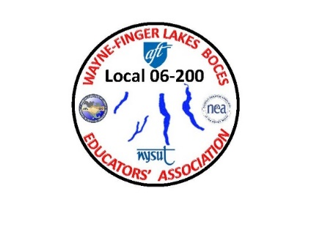

WAYNE-FINGER LAKES BOCES EDUCATORS’ ASSOCIATION

**LOCAL 06-200**

**2021 FALL GENERAL MEETING AGENDA**

1. MEETING CALLED TO ORDER

2. APPROVAL OF THE TREAURER REORT

3. APPROVAL OF THE SECERATARY

OLD BUSINESS:

1. THIS YEAR WE HAVE NOT RECEIVED ANY VOTE-COPE REBATE YET.

2. WE HAVE FILLED THE SEAT POSITIONS FOR NYSTRS DELEGATES AND ALTERNATES:

DELEGATES:  ***LORI RYAN JEANNE COSAT***

ALTERNATES: ***HEATHER KENYON JIM BUCK***

3. CONTRACT NEGOIATIONS WILL STARTING SOON/ CONTACTED UPPER ADMIN. FOR FUTURE DATES

4. SURVEY MONKEY WILL BE SENT OUT TO ALL MEMBERS BEFORE THANKSGIVING

NEW BUSINESS:

1. MEMBER TOTE BAGS WILL BE SOON FINISHED BEING HANED OUT TO ALL MEMBERS

2. LOOKING FOR BUILDING REPRESENTATIVE IN P-TECH

3. VISITING BUILDINGS / BUILDING REP SETTING UP BUILDING UNION MEETINGS

4. WE HAVE 19 NEW MEMBERS IN OUR UNION TOTAL OF 320 DUE PAYING MEMBERS

5. ERIN & QUINN /TENURE OF MEMBERS

6. COVID TESTING MEMBERS EMAIL FROM ERIN 10/6

7. NYS PAID COVID LEAVE INFO (JON HICKEY)

8. TEACHING REMOTE WHILE TEACHING IN PERSON (JON)

**NOTE: SPRING GENERAL MEETING NEEDED TO BE POSTPONED 4-13-22 DUE TO SPRING RECESS WEEK NEW DATE 4-20-22**

**NEXT EXECUTIVE COUNCIL MEETING WILL BE HELD WEDNESDAY NOVEMBER 10TH, 2021**