Greater Rochester National Board Writing Institute

Please join us either in person at Nazareth College or virtually via Zoom to work on your components. RSVP to let us know which option you will choose.

For the in person option, we will be meeting in the Golisano Academic Building rooms 51 and 53.

For the virtual option, we will email you the link. Set up in a comfortable spot at home with your laptop, earbuds, NBPTS Standards, portfolio directions and in your comfy clothes!

*Here is our contact information so that you can share components with us:*

[*Claudine Dixon*](mailto:claudine.l.dixon@greececsd.org)

[*Tina Evans*](mailto:cevans@fairport.org)

[*Jennifer Heaphy*](mailto:jheaphy1971@gmail.com)

[*Caron Lindstrom*](mailto:caron.lindstrom@gmail.com)

[*John O'Gorman*](mailto:jogorma2@naz.edu)

We are all here to help, but so is the entire group! It is a good idea to ask another colleague who teaches a different level or subject to read your work. If it makes sense to them, you know you are writing clearly! You are highly encouraged to exchange papers with each other!

|  |  |
| --- | --- |
| Retreat 1 | Retreat 2 |
| **February 11th, 4-7 p.m.**  **February 12th 8 a.m.-4 p.m.** | **April 29th, 4-7 p.m.**  **April 30th 8 a.m.-4 p.m.** |

Please [RSVP](https://docs.google.com/forms/d/1fze9UV8xFjRKfCIeXM8hESO9ilwDrFJBt2zMC4wr7RA/edit) here for the February retreat.

Contact [Caron.Lindstrom@gmail.com](mailto:Caron.Lindstrom@gmail.com) with any questions.

Sponsored by:

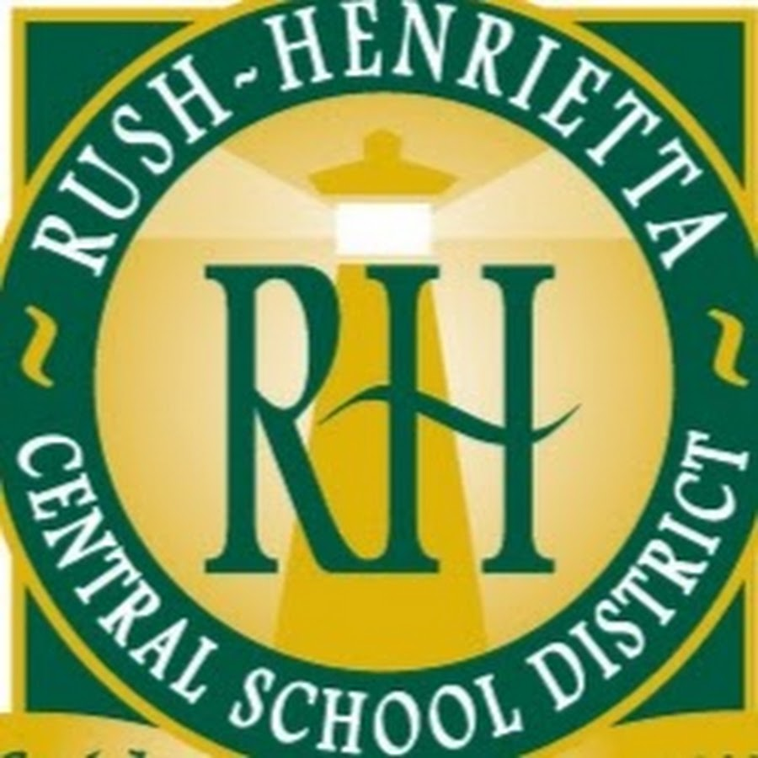 

Teacher Center

**Additional Information on NBC, graduate credit and more:**

* **[National Board for Professional Teaching Standards](http://www.nbpts.org)**
* [**National Board Council of New York**](http://www.nbcny.org)
* [**NYSUT ELT**](https://elt.nysut.org/)