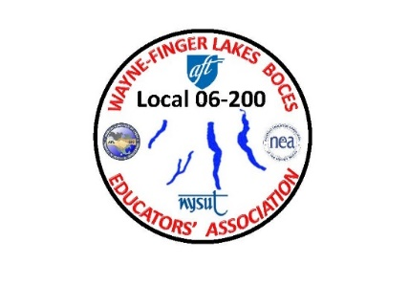 WAYNE-FINGER LAKES

BOCES EDUCATORS’ ASSOCIATION

**LOCAL 06-200**

re: Spring Meeting and Call for Nominations

Greetings to all,

All members of the Wayne-Finger Lakes BOCES Educators’ Association, are invited to attend the 2022 Spring Annual meeting, scheduled for 4:00 p.m. on Wednesday, April 20th at the Conference Centerin Newark. Tentative agenda items include Fall 2021 Meeting Minutes, Treasurer’s Report, report from EA President Jim Buck, Meet the Candidates, nominated and communicated to our Executive Secretary, **Sue Morse,** [**smmorse330@gmail.com**](mailto:smmorse330@gmail.com) **by March 31st), Last Call for Nominations, and Member Issues/Concerns.**

If you have any specific items or issues/concerns that you would like addressed at this meeting, please let Jim know (via email at **jbuck-wflbea@rochester.rr.com**) as soon as possible to facilitate inclusion on the meeting agenda.

**Nominations are requested for all Vice President positions – VP at Large, VP CTE, and VP Special Ed -- and Treasurer of the W-FL BOCES Educators’ Association. Current officers are John Erwin III, VP at**

**Large; Kathie Friedel, VP Special Ed; and Jeanne Cosat, Treasurer; Eric Navarra, VP CTE positions. The present executive members, VP of Special Ed, VP of CTE and Treasurer, are not seeking reelection.** Please use the nomination form included with letter to nominate individuals to available positions.

**Last call for nominations will be April 20th.** If there are any nominations from the floor, Sue Morse will contact named individuals to verify that they want to accept the nomination. **If there are no contested positions, voting will be conducted at the April 20th meeting. If there are any nominations from the floor, Sue Morse will contact named individuals to verify that they want to accept the nomination.**

**In the event of a contested position, candidates will have until April 28th to submit, via email, a brief bio (preferably 400 words or less) to Sue Morse, so that they can be emailed to WFLBEA members by April 30th. Voting for contested positions will be conducted by your Building/Cluster Representatives by May20th. Ballots will be counted before or at the June 8th Executive Council meeting.**

If you have any specific items or issues/concerns that you would like addressed at this meeting, please let Jim know (via email at **jbuck-wflbea@rochester.rr.com**) as soon as possible to facilitate inclusion on the meeting agenda.

The W-FL EA officers and other executive council members look forward to seeing you on April 20th.

Regards,

James A. Buck

President

W-FL Educators’ Association

jbuck-wflbea@rochester.rr.com

315-729-8263