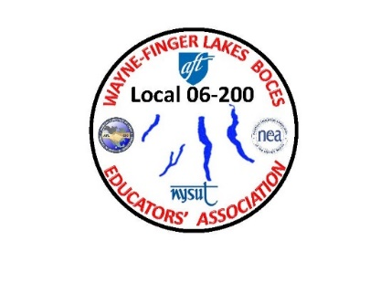

WAYNE-FINGER LAKES BOCES EDUCATORS’ ASSOCIATION

**LOCAL 06-200**

I, ________________________, being a member in good standing of the Wayne-Finger Lakes BOCES Educators’ Association, nominate ________________________ for the position of ____________________. I have contacted this person and they have agreed to serve in this position for two years…yes/no (circle one). Dated this, the ____ day of March/April, 2022.

- - - - - - - - - - - - - - - - - - - - - - - - - - - - - - - - - - - - - - - - - - - - - - - - - - - - - - - - - - - - - - - - - - - - - - - - - - - -

Please return this nomination form to Susan Morse [smmorse330@gmail.com](mailto:smmorse330@gmail.com) at Midlakes Education Center or Jim Buck at [jbuck-wflbea@rochester.rr.com](mailto:jbuck-wflbea@rochester.rr.com) at WTCC (**please put Nominations in the subject line**) for delivery by **March 31st** to facilitate bio availability. Please keep in mind that inter-office mail can take a week.

**Nominees** should submit a brief bio (less than 400 words) to Sue for delivery by March 31stth to facilitate inclusion at Annual Spring general membership meeting on April 20th). Preferred delivery method is by email to Jim Buck at jbuck-wflbea@rochester.rr.com at WTCC or Sue Morse at [smmorse330@gmail.com](mailto:smmorse330@gmail.com) at MEC but inter-office mail is acceptable.