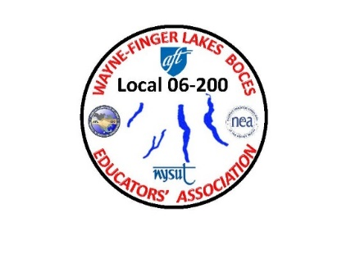 WAYNE-FINGER LAKES BOCES

EDUCATORS’ ASSOCIATION

**LOCAL 06-200**

8/5/22

Dear union sisters & brothers:

It has been a while since the last time I wrote a letter to everyone, I’ll start off with what is on my mind, and everyone else mind lately, which is negotiations with Admin and if you been working for BOCES for a while, you know how it works, it’s a slow-moving process, believe me not on our part, but on their part. We have meant four time so far with a meeting that was scheduled last month, that was canceled on their part. I cannot go into details, but what I can say is, the team and I are not backing down on our topics and we have been discussing a lot about wording and the changes that has been in the contract for a long time, that has not been changed over 14 years.

Trust me, it is not all about the wording, we have been in discussion of the same two things that is always the main topics at every negotiation meeting: salary and insurance. It is tough and very frustrating on our part, especially when we gave them what we are asking for and it is taking them this long to come to a compromise. We do have a meeting with Admin. this month on the 24th, we are hopeful that we can reach an agreement so that we can bring it to all of you.

My goal, once we come to an agreement, The negotiation team and our NYSUT LRS, will be planning on having 3 in person meetings. One in the south area, one in the middle, and one up in the north area.

I will be looking for you all to come to one of these meetings, once we have the dates set, to be able to ask questions and to vote. I am sorry for not keeping you all informed of our meetings, because there has not been much to inform you about. I am hopeful that our next meeting coming up this month with Admin, that we can come up with an agreement for both sides to be satisfied about this contract and move on.

I also want to address concerns that some members are seeing at different locations through out WFLBOCES, and that there is members that are resigning from their positions and leaving BOCES.

I heard from some members it is because of no contract yet, some members are leaving because they are finding positions closer to home, some are finding positions within a different school district that is paying more, and so forth. Everyone of these people have their own reasons, which I can’t go into detail about.

In closing, I want to thank you all for all that you do, especially this school year. For some of you, just a few more weeks left before summer school will be over and for some having summer off has been great, and for some people working at a summer job has been their thing. Which ever group you are in; please take some time for yourself these few weeks left relax a little and get rejuvenated. We all need it.

In Solidarity,

Union President

Jim Buck