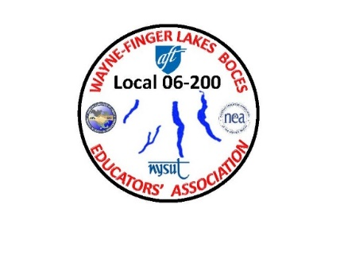WAYNE-FINGER LAKES BOCES

EDUCATORS’ ASSOCIATION

**LOCAL 06-200**

**2022**

**WFLBEA MEMBER'S UPDATED INFO**

WAYNE FINGER LAKES BOCES EDUCATORS' ASSOCIATION MEMBER'S UPDATED INFORMATION

* Member’s Name: ________________________________________________________
* NYSUT membership number: _______________________________
* Personal Email Address ONLY: ______________________________________________________
* Home mailing Address: _______________________________________________________________

___________________________________________________________________

* Phone number: ________________________________________
* Please check what building you work out of:

As Per Assigned

FLSS

FLTCC

MEC

NEC

P-TECH

RJEC

RSC

WEC

WTCC

Other