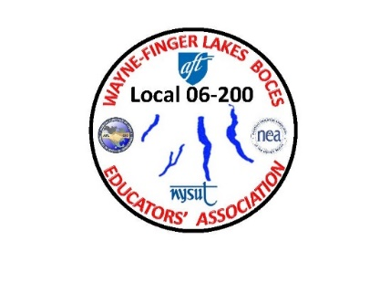 **WAYNE-FINGER LAKES BOCES**

**EDUCATORS’ ASSOCIATION**

**LOCAL 06-200**



**WAYNE-FINGER LAKES EDUCATORS’ ASSOCIATION FALL MEETING**

**WEDNESDAY OCTOBER 12TH**

**4:00 PM**

**@**

**THE CONFERENCE CENTER**

**NEWARK, NY**

**In Person or via zoom**

**Join Zoom Meeting:**

[**https://edutech.zoom.us/j/2032195058?pwd=d0dtVkp1anpjck5ZYmNCTzZaa0FDUT09**](https://edutech.zoom.us/j/2032195058?pwd=d0dtVkp1anpjck5ZYmNCTzZaa0FDUT09)