Please share this information about NYSUT’s certification webinars with your members.

We know that certification in New York State can be complicated and stressful. That's why NYSUT has an office that's entirely devoted to helping our members navigate the certification process. While the State Education Department manages all certifications, our certification experts are here to give you answers and help you through the process.

NYSUT is pleased to offer a new range of free webinars to help our members with their certification questions. These webinars are designed to help NYSUT members with specific challenges they encounter understanding and managing their certifications.

Space in each webinar is limited. Please sign up only if you plan to attend.

Webinars are free for NYSUT members.

Visit this WEBSITE to register
Thanks,
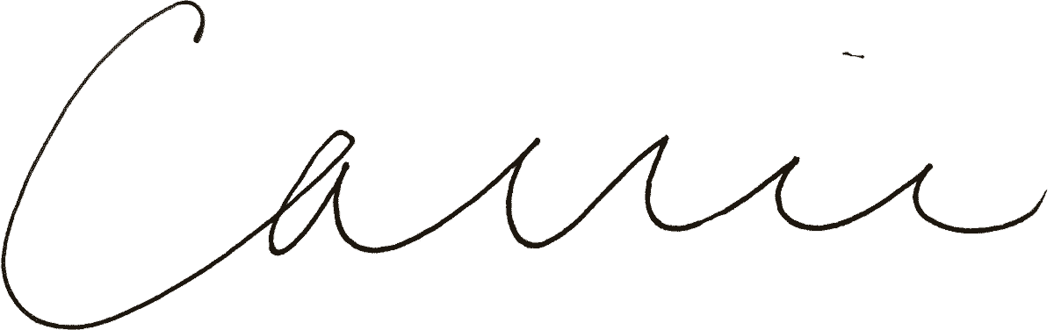
Carrie M. Andrews
Regional Staff Director

