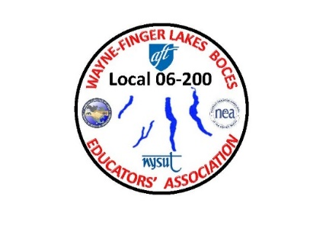WAYNE-FINGER LAKES BOCES

EDUCATORS’ ASSOCIATION

**LOCAL 06-200**

**Spring General Meeting**

**April 19th, 2023**

**Conference Center, Newark, NY 14513**

* **Meeting Called to order.**
* **Pledge of Allegiance**
* **Approval of the Secretary’s report from Fall Meeting October 12th**
* **Treasurer’s Report: Annual Financial report**

**Old Business:**

* **In need of Building Reps in the following locations:**
  + **2-WEC, 1-PTech,**
* **Did not receive any nominations, but we are in need for 2 Delegates and 2 Alternates for the NYSTRS Conference. The conference is held in Saratoga Springs in the Fall/Winter. These delegate positions are for a two-year seat. Please see the outline and requirements for these positions (also in the attachments)**
* **Results of an un-contested election for the following officers:**

**Renew 2-year position / In the event of an election where all candidates are unopposed and in compliance with conditions specified by LRMDA/ Landrum-Griffin, the use of a secret ballot is not required, and the election vote will be finalized by a single vote of an Executive Board member not on the ballot**

* **Union President- Jim Buck**
* **Secretary – Sue Morse**

**New Business:**

* **Teachers appreciation week May 7th-13th, 2023 (Chelsea)**
* **Updating WFLBEA Constitution & Bylaws with constitution committee**
* **Ride or Drive for Ed/ in the workings - meeting on the 26th with upper admin to go over details.**
* **Making Strides Against Breast Cancer 10/22/23**

**Looking for a Team Leader for our local by May 31st,23**

* **FREE DASA Training for all NYSUT members April 25th & 26th**

[**https://elt.nysut.org/learning-centers/rochester-western-ny**](https://elt.nysut.org/learning-centers/rochester-western-ny)

**For Executive Council Members only:**

* **May 15th BOCES Leaders/President Dinner (NYSUT-Rochester)**
* **August 15th-17th Summer Leadership Conference @ Greek Peak (Cortland)**
* **February 2nd-3rd 2024 Winter Conference @ Hyatt Hotel ( Rochester)**
* **Please visit the Union website for union information:** [**www.wflbea.org**](http://www.wflbea.org)