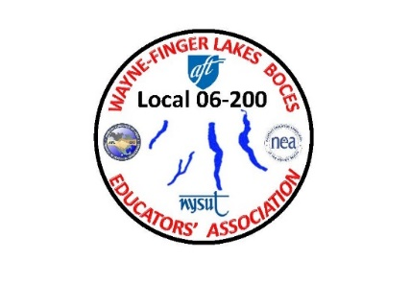 **WAYNE-FINGER LAKES BOCES**

**EDUCATORS’ ASSOCIATION**

**LOCAL 06-200**

**WAYNE-FINGER LAKES BOCES**

**EDUCATORS’ ASSOCIATION**

**FALL MEETING**

**WEDNESDAY OCTOBER 11TH**

**4:00 PM**

**@**

**THE CONFERENCE CENTER**

**NEWARK, NY**

**In Person/ Via Zoom**

**Join Zoom Meeting**

[**https://edutech.zoom.us/j/2032195058?pwd=d0dtVkp1anpjck5ZYmNCTzZaa0FDUT09**](https://edutech.zoom.us/j/2032195058?pwd=d0dtVkp1anpjck5ZYmNCTzZaa0FDUT09)