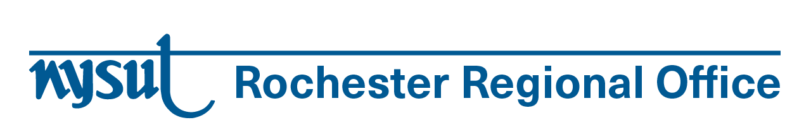
Dear Local President,

Please share this email with your teachers of English Language Learners.

NYSUT is offering a 90-minute online seminar designed for teachers of English Language Learners (ELLs). Participants will earn 1.5 CTLE hours for Language Acquisition. The seminar will be taught by NYSUT Executive Vice President Jaime Ciffone and NBCT teacher, Susan Lafond. The seminar is being offered on December 4 and December 11. (It’s repeated.) It is free for NYSUT members only.

From Awareness to Action: Strategies for Effective Instruction with Newcomer ELLs
Join us for an immersive and dynamic training designed specifically for teachers of English language learners (ELLs). This 90-minute session focuses on equipping educators with practical strategies to foster an inclusive atmosphere, heighten their understanding of language development's role in instruction, and employ engaging activities that facilitate student learning and linguistic advancement, including Newcomer and SIFE students. By utilizing a case study, attendees will have a unique opportunity to apply the strategies learned, encouraging practical implementation and deeper comprehension of how to effectively support linguistically diverse learners in their educational journey.

Advanced registration is required and class size is limited to 50. Register here: https://bit.ly/FromAwarenesstoAction

You will receive a Zoom link the week before the date of the class.

