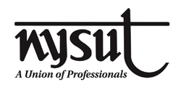
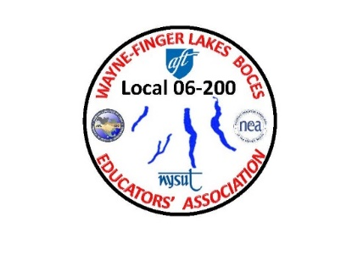
WAYNE-FINGER LAKES BOCES
EDUCATORS’ ASSOCIATION
LOCAL 06-200

12/18/23

Dear WFLBEA Union Members:

My last letter to all of you was around August of this year. Since then, a lot of things have happened. We have a new DS, Lynne Rutnik. I have meant with her in a private one on one conversation for over an hour already. Which we discussed numerous topics, from having our own certification officer to 12 pages of concerns that were handed to me to give her from various BOCES sites. I will be setting up another meeting with Lynne after the holidays are over with not only our local but with the support staff and the principal’s local, to discuss those same concerns/issues that have not been addressed as of yet.

On November 29th, I had a NYSTRS Board Member, Beth Chetney, who is also a teacher and union president for the Baldwinsville school district to come to the Conference Center and present and answer any questions that members might have had regrading retirement. We had a very well turn out. I am looking to do this once again before the end of the school year for anyone who might have missed it.

The officers of the union with the help of NYSUT, put out a survey about what you as a member feel about your local. We did get a substantial number of members that did respond for the officers to look at and see how we can make our local a better local.

Our local, Wayne Finger Lakes BOCES Educators’ Association (WFLBEA) is celebrating our 50th anniversary this year, and in my last letter I mentioned that the Executive council has come up with some new ideas for the members, and one of them has already started this month. It is called our Union’s Random Acts of Appreciation! Some members have already started to receive the different gifts. I would like to say that there are more to come.

Please visit our website, www.wflbea.org The password is union. Please if you haven’t and I know there are many of you who haven’t gone on our local site, there are weekly post from NYSUT, with different training programs for members, there is our contract, that everyone is looking at, the local constitution and bylaws, and the new calendar for the BOCES board meetings, Executive Council monthly meetings and the two General Membership meetings dates. If there is anything that you would like to have posted on our website, such as fundraisers, special events, building events, student events, please contact me. If you have some pictures, please send them and I will make sure to post them for everyone to see. Which reminds me that this coming spring, there will be different activities happening with our local to help support our community in and around all our buildings.

I mentioned about our Constitution and Bylaws, it had been updated and voted on by the Executive council to send it out to the members via email and for the members to be able to vote on the updates. This will take place once we return from the holidays.
I would like to thank all of you for working with your building reps, in getting any new information that needed to be changed on your NYSUT/WFLBEA membership. Such as email addresses, last names, building locations, mailing addresses, and much more. Within the last few weeks, we were able to update 100% of the members, including our on-line instructors and now have them listed per building dept. I like to thank you all for helping with this.

Since the beginning of the school year, we have had over 17 new members joined our local, some are new to teaching, some are transfers from other school districts. In the next week I will be putting their name on our website and the buildings they are in so that, you can say welcome and make them feel at home.

Which brings me to my next point. I want to let all members know that I will be visiting the different BOCES buildings to hear about any issues that have come up that haven’t been resolved and just to meet with members. Our BOCES, just like other BOCES and school districts, are seeing a major change of personnel. Members are retiring and/or relocating and finding different employment opportunities. I know that we have a shortage of staff, just like other schools and BOCES. The shortages are everywhere. If you like me to come to your building to talk to the members, please feel free to contact me, or contact your building rep and I will be there. This week I was at MEC.

Beginning of the month, I was in Albany for the weekend for our quarterly BOCES president leadership weekend. One of the main topics was shortages of staff, both in ours and in support. This was across the board from every BOCES across the state, they too have seen and have a major shortage. It’s not just one thing, such as money or insurance, it is about many different things that one center offers and the other doesn’t, such as being able to teach from home still, just to name a few. Sorry, I’m one of them who don’t want that to happen again.

I am writing this letter to let members in our local to know that I am not only the WFLBEA local union president, but also a teacher. I do want members to feel free to contact me about issues that concern them. I can’t guarantee that I am able to fix your problem, but I will look into it and help to come up with a solution.

I encourage all of you to get involved with your local Union. There are many Committees that currently need more members. With just a few minutes of your time, you CAN MAKE A DIFFERENCE, making our Local succeed another 50 years. If you are interested in getting involved, don’t hesitate to contact me directly or contact any building representative. The list of the Executive Council Members and their contact information is posted on our Local’s website.

Lastly, I want to wish all of you a very Merry Christmas and a Happy New Year. Please, enjoy the time off and enjoy the time being spent with family and friends, you all deserve it, and I hope to see everyone of you when I visit your buildings soon.

In Solidarity,

Jim Buck

