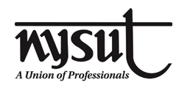
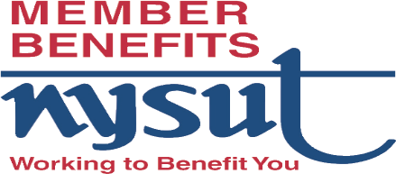
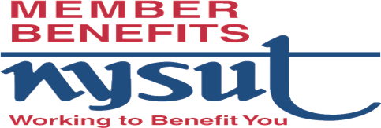

WAYNE-FINGER LAKES BOCES EDUCATORS’ ASSOCIATION
IN CONJUNTION WITH
WAYNE-FINGER LAKES BOCES ASSOCIATION OF
SCHOOL SUPPORT PERSONNEL
SPONSORING IN PERSON PRESENTATION

PRESENTED BY JACKIE DAVIS
Benefits Coordinator, NYSUT Member Benefits
FOR ALL UNION MEMBERS

WHEN: TUESDAY MARCH 19TH @ 4:00 PM
WHERE: THE CONFERENCE CENTER, NEWARK, NY
FIND OUT HOW
NYSUT MEMBER BENEFITS
CAN HELP YOU SAVE MONEY
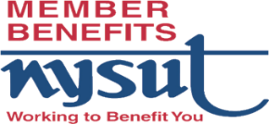
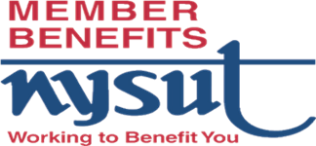
Food & Drinks will be provided

