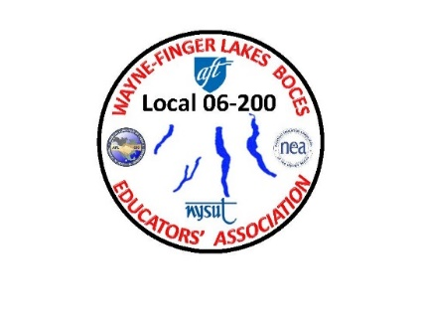
WAYNE-FINGER LAKES BOCES EDUCATORS’ ASSOCIATION
LOCAL 06-200

Notice of Nominations

Nomination Ballot for WFLBEA Vice President @ Large/ Vice President of CTE/ Vice President of Special Education/ Executive Treasurer

I ________________________________, being WFLBEA dues paying union
Print your name
member in good standing is nominating, ______________________________
Print the person’s name
who is a WFLBEA dues paying union member in good standing. I have contacted this person and they have agreed to serve in this position for two years.
Please use one ballot per position when voting.
For one of the following positions.

WFLBEA Vice President @ Large…………….
WFLBEA Vice President of CTE………………..
WFLBEA Vice President of Special Ed……….
WFLBEA Executive Treasurer………………….

- - - - - - - - - - - - - - - - - - - - - - - - - - - - - - - - - - - - - - - - - - - - - - - - - - - - - - - - - - - - - - - - - - - - - - - - - - - -

Duties of the Vice Presidents and Executive Treasurer are included on the following page.

Please return this nomination form to Susan Morse by email at smmorse330@gmail.com or (please put Nominations in the subject line) for delivery no later than March 28th by 5:00PM Please keep in mind that inter-office mail can take a week.

Nominees should submit a brief bio to Sue for delivery on or before March 28th, 2024 by 5:00 PM (to facilitate inclusion at Annual Spring general membership meeting on April 17th). Preferred delivery method is by email to smmorse330@gmail.com but inter-office mail is acceptable.

Nominations for Vice Presidents and Treasurer
Job title descriptions

Duties of the Vice Presidents & Treasurer are included on the following page.

Please return this nomination form to Susan Morse by email at smmorse330@gmail.com or (please put Nominations in the subject line) for delivery no later than March 28th by 5:00PM Please keep in mind that inter-office mail can take a week.

Nominees should submit a brief bio to Sue for delivery on or before March 28th, 2024 by 5:00 PM (to facilitate inclusion at Annual Spring general membership meeting on April 17th). Preferred delivery method is by email to smmorse330@gmail.com but inter-office mail is acceptable.

b. Duties of the Vice President at Large:
1. Assume the duties and responsibilities of the President in case of his/her absence or disability.
2. Perform such other duties as the President may request.
3. Represent as a cluster rep to members who are “as assigned per BOCES” and that are not
otherwise represented.

c. Duties of the Technical & Career, and Special Education Vice-Presidents:
1. Serve on their respective SDM Core teams.
2. Each Vice President should pursue issues in their respective programs.
3. Perform such duties as the President may request.

e. Duties of the Treasurer:
1. Assume the responsibility for the funds of the Association, deposit them in the name
of the Association and disburse them upon authorization by the Executive Council.
2. Maintain complete records and accounts of moneys received and disbursed.
3. Prepare an annual budget of the Association to be presented to the active membership at
the first General meeting for the school year.
4. Keep the President and the Executive Council informed of the financial condition of
the Association.
5. Notify non-members of their options.
6. Comply with all fiscal policies and procedures of NYSUT and its national affiliates.
7. Perform such duties as may be required by the President or Executive Council.

