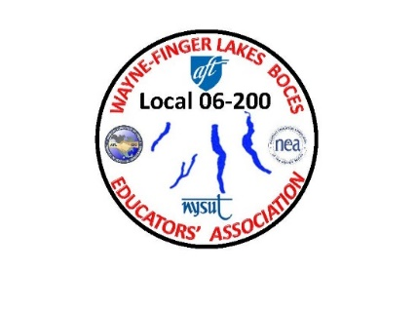



**Wednesday April 17th, 2024@ 4:00 PM**

***WAYNE FINGER LAKES BOCES***

***EDUCATORS’ ASSOCIATION***

***LOCAL 06-200***

***PIZZA AND DRINKS WILL BE PROVIDED***

**Join Zoom Meeting@**

[**https://edutech.zoom.us/j/2032195058?pwd=d0dtVkp1anpjck5ZYmNCTzZaa0FDUT09**](https://edutech.zoom.us/j/2032195058?pwd=d0dtVkp1anpjck5ZYmNCTzZaa0FDUT09)

***Agenda items include:***

***Fall 2023 Meeting Minutes & Election of All Vice Presidents and Executive Treasurer***

***&***

***MELINDA PERSON OUR NEW NYSUT UNION***

***PRESIDENT WILL BE PRESENT TO SPEAK TO THE MEMBERS***

***FOOD & DRINKS WILL BE PROVIDED***

**In Newark @ The Conference Center**